**Climate Dynamics Summer 2024 Findings**

Christopher Seybold

**Introduction**

Climate science is an exciting and rapidly evolving field, brimming with new technological applications and opportunities. As humanity faces the pressing challenges of climate change and an increasing number of extreme weather events, researchers are turning to cutting-edge technologies like artificial intelligence to develop more accurate predictive models, enhance climate resilience, and mitigate the impacts of dangerous weather-related incidents. During my summer research experience, I explored newly developed AI weather models and built a predictive model for fire danger. These projects not only deepened my understanding of climate dynamics but also showcased the promise that AI has in addressing some of the most critical environmental issues of our time.

**Case Study: September 2020 Western United States Extreme Weather Event**

To begin my research, I first delved into the paper titled “The Meteorology and Impacts of the September 2020 Western United States Extreme Weather Event” by Emma N. Russell et al. This paper provided a comprehensive analysis of the meteorological conditions that led to the extreme weather event in September 2020, which included the rapid spread of several large wildfires in the Pacific Northwest and record-breaking cold temperatures in the Rocky Mountains.

The researchers used synoptic analysis and air parcel backward trajectories to understand the event. They identified a highly amplified 500 hPa tropospheric wave pattern as the primary atmospheric driver. This pattern included a record-breaking ridge of high pressure to the west and a trough of low pressure to the east. The dry air over the Pacific Northwest, which exacerbated the fire danger, originated in the mid-troposphere and descended to the surface through subsidence.

**AI Weather Models: Pangu-Weather and ForecastNet**

After familiarizing myself with fundamental concepts from climate science, I began investigating the capabilities of recent AI weather models such as Huawei’s Pangu-Weather and NVIDIA’s ForecastNet. These large-scale systems process vast amounts of data from various sources, including satellite observations, climate sensors, and historical records, and utilize deep learning algorithms to identify intricate patterns and relationships within the data that traditional methods might miss. By training on decades of historical weather 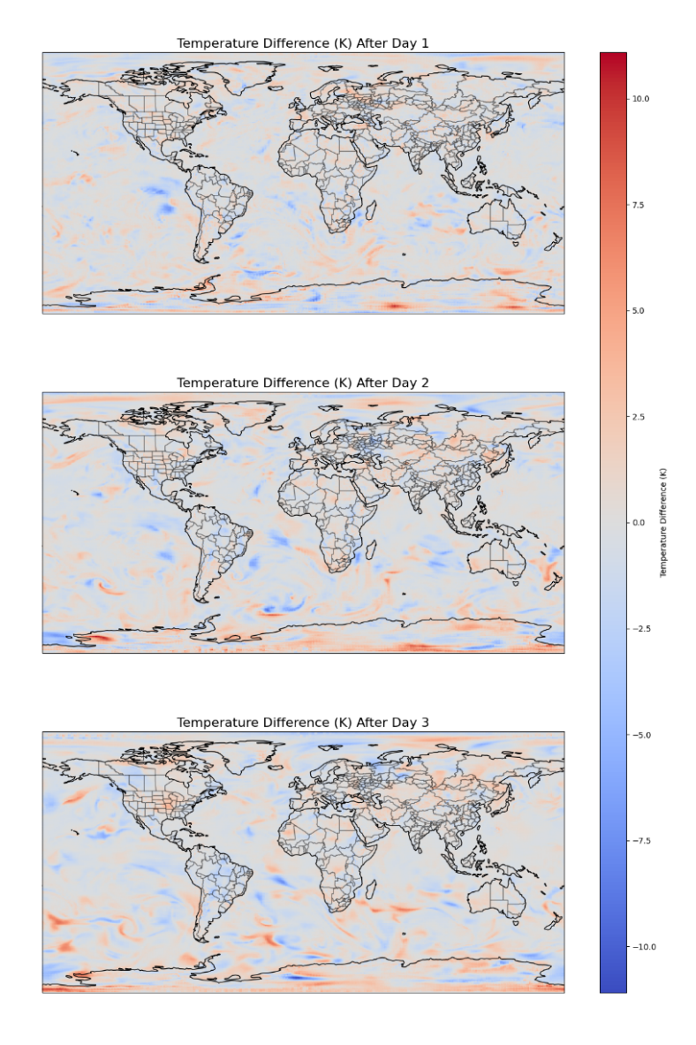data, these models can generate forecasts with unprecedented speed and precision. To test their robustness, I first computed the differences in global 850 hPa temperature forecasts between the two models over a three-day period, as shown in figure 1. Here, regions of red indicate higher predictions from Panguweather.

After one, two, and three days, Panguweather’s average predictions were 0, 0.02, and 0.06 Kelvins higher than ForecastNet’s, respectively. These minute differences show no obvious geospatial pattern, but it would be interesting to investigate how the two models interpret land and climate conditions differently, what exactly leads to differences in predictions, and which model is more reliable overall.

Given that both models have demonstrated superior precision compared to traditional numerical weather prediction methods for forecasts ranging from one hour to one week, a key differentiating factor lies in their ability to predict highly unusual weather events. PanguWeather, in particular, excels in predicting cyclones, marking a significant advancement towards forecasting other types of extreme weather events. However, both models exhibit limitations in this regard. For instance, their daily 850 hPa temperature predictions consistently varied by over 0.5 Kelvins during the Creek Fire over a span of three days. While this difference may seem minor at first glance, it is ten times larger than the average variation observed on a global scale, even at around 5000 feet above sea level, indicating that the fire weather may not have been adequetly captured by the models.

**Figure 1**

For the sake of future research and development, it would be highly beneficial to study instances where these models produce forecasts that deviate from physical realism and explore how integrating known physical equations and constraints into the models could help ensure highly accurate and realistic predictions. Another notable improvement to be made is taking more metrics into account, such as soil moisture, solar radiation, visibility, and ozone levels, which all have important applications across several industries ranging from agriculture to aviation. These limitations, combined with the need for extensive validation, trust-building, and adaptation to existing infrastructure, mean that integrating these models into operational forecasting systems remains a challenge.

**Reproducing Figures and Results**

Recognizing the significance of Russel’s paper and the highly unusual weather events taking place at the time, I chose to reproduce some of the figures to both validate the accuracy of AI weather models in capturing complex meteorological phenomena and highlight their potential for operational use in forecasting and climate studies. By achieving near-identical results, I demonstrated that AI-driven models can enhance our understanding and prediction of extreme weather events, contributing to better preparedness and mitigation strategies.

To familiarize myself with the plotting process, I began by generating a 4-day 1000 hPa temperature prediction from September 1 to 4, 2020, the days leading up to the 2020 CA Creek fire, as shown in figure 2. A major heat surge can be seen in the western and southern US, especially in a distinct band extending from California to Texas, which posed an increased fire danger. This initial step allowed me to understand the data handling and visualization techniques required for more complex analyses.

Fig 2. Temperature (K) at 1000 hPa across Western North America, including the Pacific Northwest and parts of the Rocky Mountains. Latitudes range from 20°N to 70°N, longitudes range from -150°W to -100°W, and gridlines shown every 10°.

**Figure 2**

Building on this, I successfully reproduced Figures 2 and 3 from the aforementioned paper using Pangu-Weather. For Figure 2, I selected the relevant variables, such as 250 hPa geopotential height and wind components, and computed wind speed. For Figure 3, I focused on the 3-day 500 hPa geopotential height anomalies, computing anomalies in standard deviations. The resulting plots closely matched the original ones from the paper, as can be seen in this paper’s figure 3.

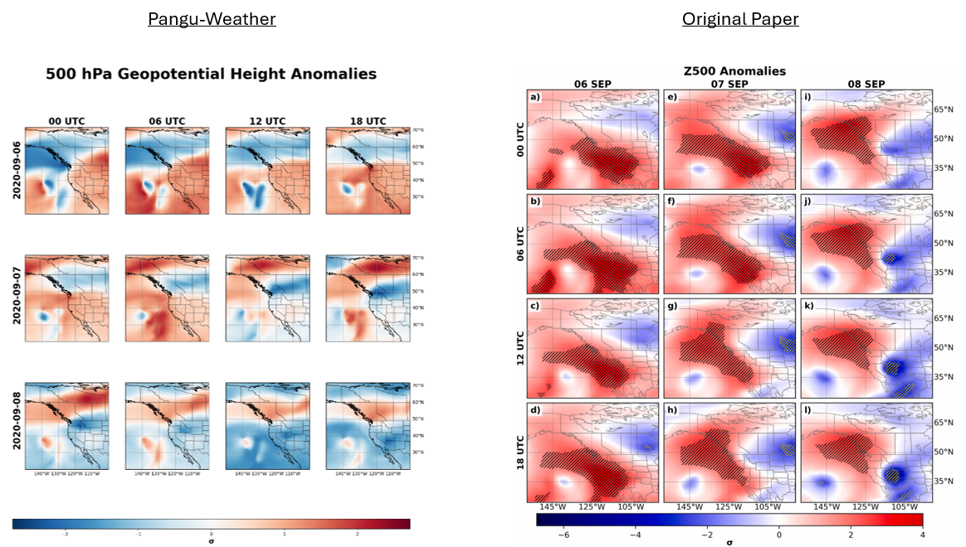

**Figure 3**

The major geopotential height anomalies, or ridges, that occurred around the time of the creek fire are often associated with clear skies, sinking air, and warm and dry conditions. The high wind speeds, which reached over 80 m/s in a tunnel arching over California, also have a large influence on weather patterns, storm development, and atmospheric transport. Pangu-Weather’s ability to accurately predict these crucial fire indicators underscores its potential for identifying regions where disasters can occur, which is an exciting step forward for scientists who can use this information to help mitigate the damage done by extreme weather events. Overall, these newly developed AI-based weather models hold an enormous amount of promise, and although there are plenty of improvements to be made, they signify a bright future for the field of climate science.

**Project 2: Predictive Model for Fire Danger**

The increasing frequency and intensity of wildfires pose a significant threat to ecosystems, human lives, and property worldwide. Traditional methods of wildfire prediction, which rely heavily on empirical models, often fall short in accurately forecasting fire occurrences due to their limited spatial and temporal resolution. In recent years, AI has emerged as a transformative tool in enhancing wildfire prediction and prevention due to its ability to analyze vast amounts of multimodal data, thereby detecting and classifying fire hotspots. This section explores my statistical analysis and model development processes aimed at enhancing wildfire prediction accuracy, which aligns with the major technological advancements currently being made in this field.

**Statistical Analysis and Model Development**

My analysis commenced by establishing a baseline dataset characterizing typical wildfire conditions, which was retrieved from the National Interagency Fire Center. I used Python’s Meteostat library, which is based on government records, to gather data on key meteorological variables, such as temperature, precipitation, wind speed, and atmospheric pressure at the starting time of each wildfire. Google Earth API also provided a highly useful vegetation index and mean fire return time for each relevant location, which was sufficient to form a solid foundational model to predict fire risk. I first calculated the mean and standard deviation of each variable to obtain a standardized metric to assess the relative fire risk for any given location and date. Users could input their desired location and date, and the system would compute the number of standard deviations each meteorological variable deviated from the historical average, providing a quantitative measure of fire risk. However, I realized the model lacked data representing other weather conditions, which are crucial for comparison.

To address this, I integrated a comprehensive weather dataset from Kaggle to establish a 5-class weather classification system, capable of predicting "Fire", "Sunny", "Cloudy", "Rainy", or "Snowy" conditions. To achieve this, two distinct machine learning models were employed: a Support Vector Machine (SVM) and a custom-designed 14-layer neural network architecture. This multifaceted approach aimed to provide a more robust and nuanced understanding of weather conditions and their potential association with wildfire occurrences. The SVM achieved a testing accuracy of 87.4%, while the neural network had an accuracy of 86.58%. I also generated confusion matrices were used to further analyze the results, which can be seen in figure 4.

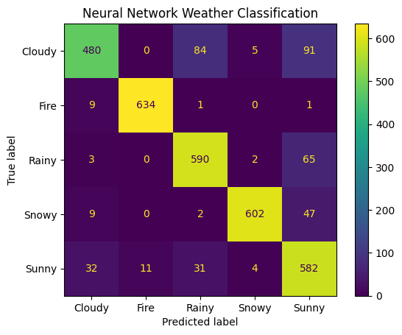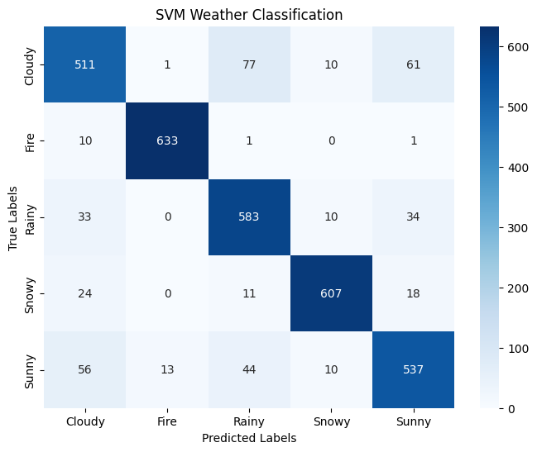

**Figure 4**

**Model Testing and Future Directions**

When tested on the meteorological conditions one day before the devastating Creek Fire, the SVM predicted a 90.58% probability of fire, while the neural network yielded an 88.76% probability. While these probabilities may exhibit a tendency towards overestimation, the results are nonetheless highly promising. They suggest that machine learning models, trained on comprehensive weather and wildfire data, hold the potential to serve as valuable early warning systems, identifying areas at elevated risk of wildfire ignition and enabling proactive fire prevention and mitigation strategies.

To further refine the accuracy and reliability of these models, future research could explore incorporating additional variables, such as satellite imagery, topography, and human activity patterns, as well as selectively considering data from surrounding areas to not only improve extreme weather event inferences, but to predict wildfire spread patterns, identify ideal boundary lines for containment, or forecast other important metrics.

**Conclusion**

This research underscores the transformative potential of artificial intelligence and machine learning in enhancing our comprehension and prediction of wildfire risk and other weather events, particularly within the context of a changing climate. While current models demonstrate promising predictive capabilities, continued advancements in this dynamic field are essential. Further research focusing on data refinement, model optimization, and the integration of diverse environmental and anthropogenic variables holds the promise of yielding even more accurate and reliable wildfire predictions. The implications of such progress are far-reaching, with significant potential to improve wildfire prevention strategies, optimize resource allocation for firefighting efforts, and enhance community resilience in fire-prone regions. Moreover, the development of sophisticated AI-powered weather models has broader implications, extending beyond wildfire prediction to revolutionize fields like agriculture, urban planning, and disaster response, ultimately contributing to a more sustainable and resilient future.